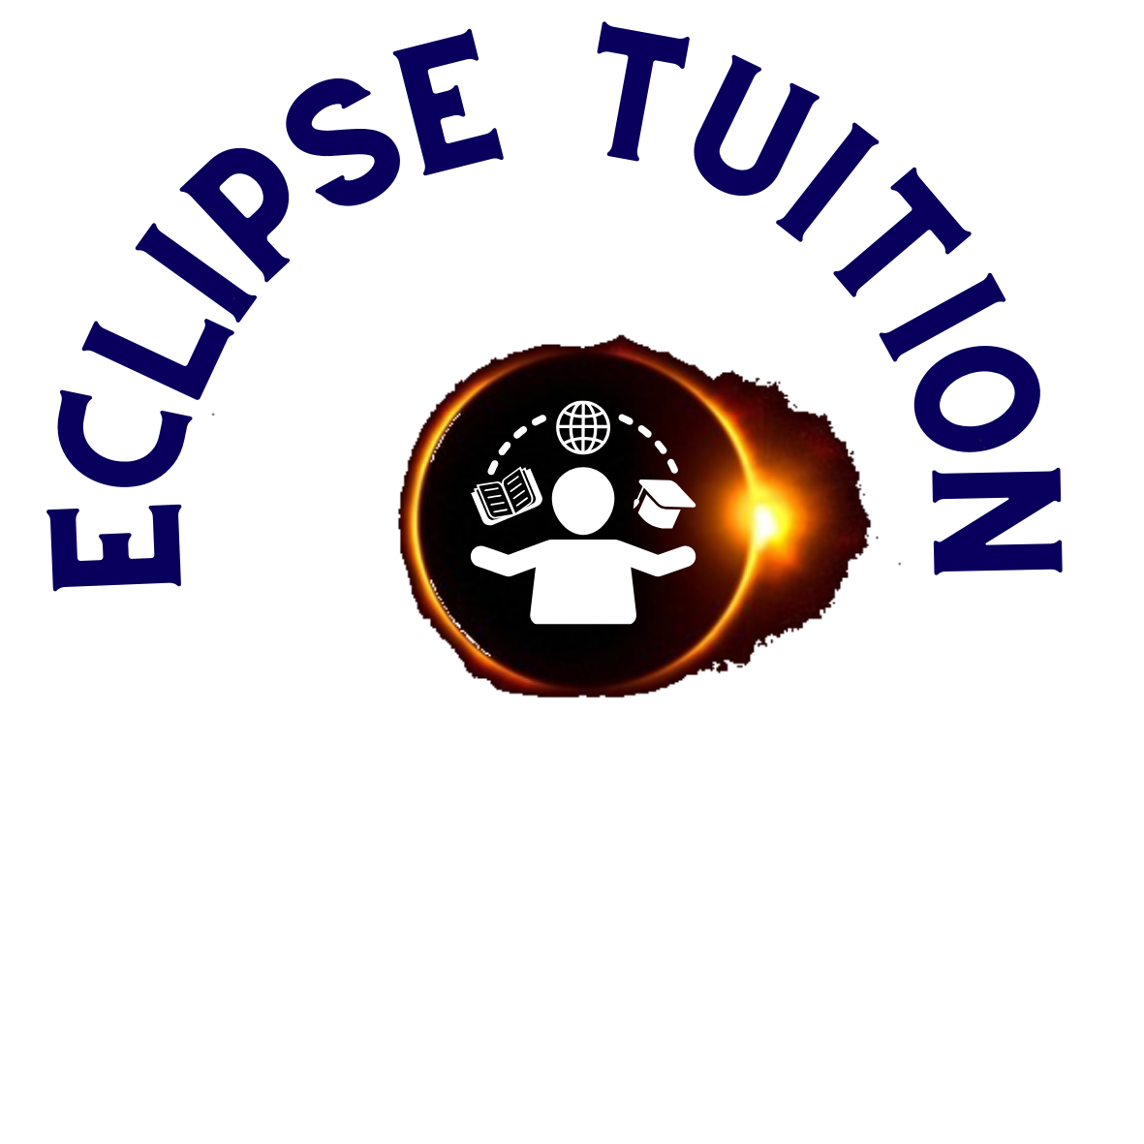
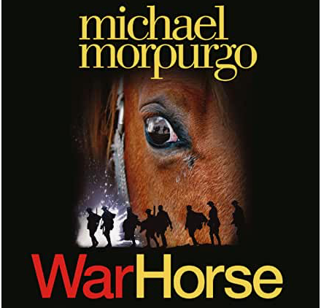
Recommended Reading

Jenny Nimmo- 'Snow Spider'
David Long-'Survivers'
EvaIbbotson- 'Journey to the River Sea' and 'Star of Kazan’
Abi Elphinstone-‘Dream Catcher' series
Emma Carroll books-Letters from the Lighthouse, in Darkling wood
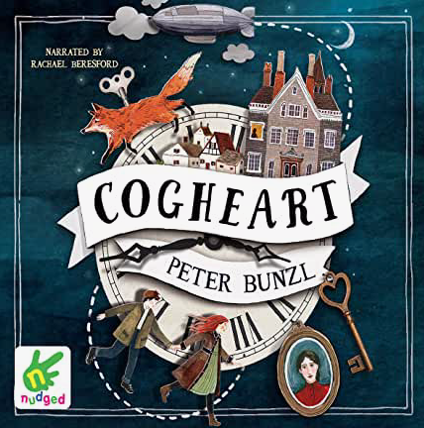
Warrior Cats series -Erin Hunter

Cornelia Funke- ‘Inkheart trilogy'
Michael Morpurgo- particularly ‘War Horse’, ‘Running Wild’, ‘King Arthur’ and ‘Kensuke’s Kingdom’
Phillip Pullman - His Dark Materials- “Northern Lights’, ‘Subtle Knife’ and “Amber Spyglass’
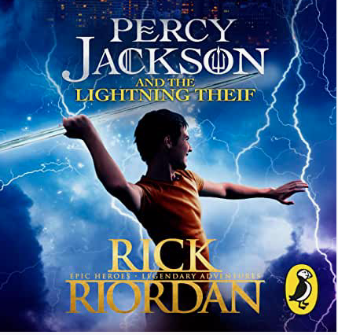
Phillip Pullman- Grimm Fairy tales
Any Greek myths, there is a good myths and legends book written by Anthony Horowitz
Percy Jackson series-Rick Riordan

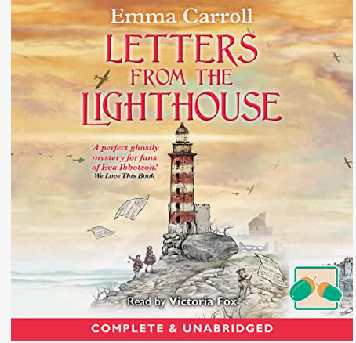
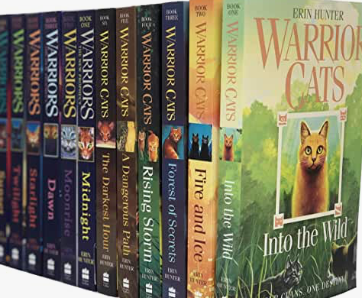
Geraldine McCaughrean-'Death Defying Pepper Roux' and 'Peter Pan in Scarlet'
David Almond- 'Skellig'
Madeleine L'Engle- 'A Wrinkle in Time'
Joan Aiken- 'The Kingdom Under the Sea’
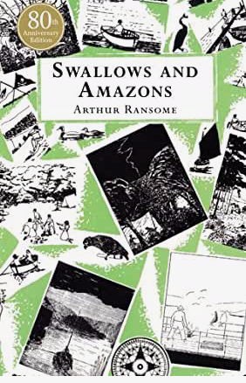
Joan Aiken-Wolves of Willoughby series
Erich Kastner 'Emil and the detectives'
Phillips Pearce -'Tom's Midnight Garden’
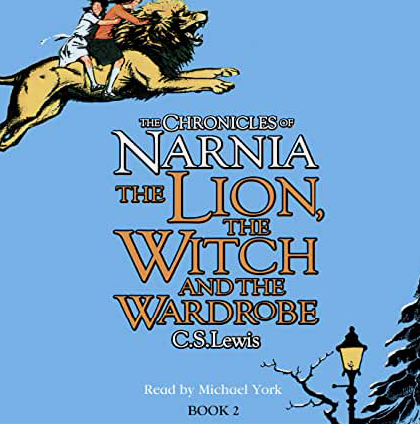
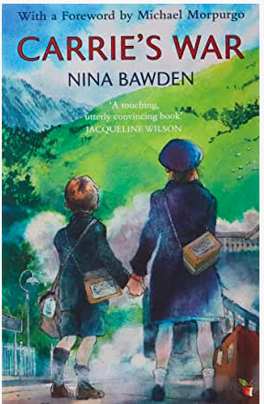
Eoin Colfer-‘Artemis Fowl’
Peter Bunzl- Cogheart series

Reading from Classic books:
Lewis Carroll- 'Alice in Wonderful'
France's Hodgson Burnett- 'The Secret Garden'
L.M.Montgomery- 'Anne of Green Gables'
Nina Bawden- ‘Carrie’s War’
JM Barrie- 'Peter Pan'
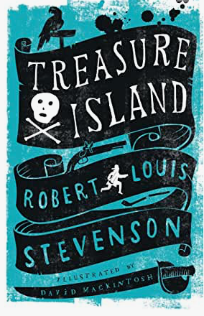
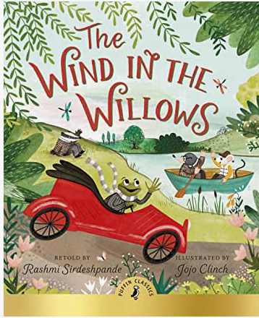
CS Lewis Chronicles of Narnia series, all fantastic! Start with 'The Lion, the Witch and the Wardrobe'
ES Nesbit- ‘Five Children and It’, “Phoenix and the Carpet’
Arthur Ransome- ‘Swallows and Amazons’
Tolkein- ‘Hobbit’ and Lord of the Rings
Anna Sewell-‘Black Beauty’
Kenneth Grahame- ‘The Wind in the Willows’
Robert Louis Stevenson- 'Treasure Island'
Mary Norton -'The Borrowers’
Robert C O’Brien-‘Mrs Frisby and the Rats of Nimh’
Jonathan Swift — Gulliver’s Travels
Hans Christian Andersen — The Complete Fairy Tales

