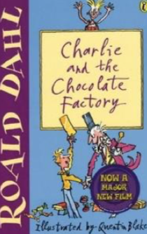
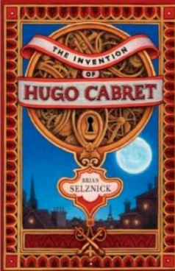
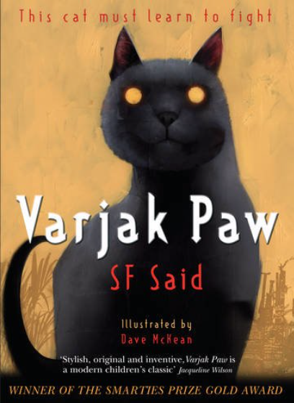
Book Recommendations for Year 3 and Year 4
Roald Dahl books -any of his books.
Dick King-Smith-‘The Sheep Pig’
Michael Morpurgo-‘Butterfly Lion’ and

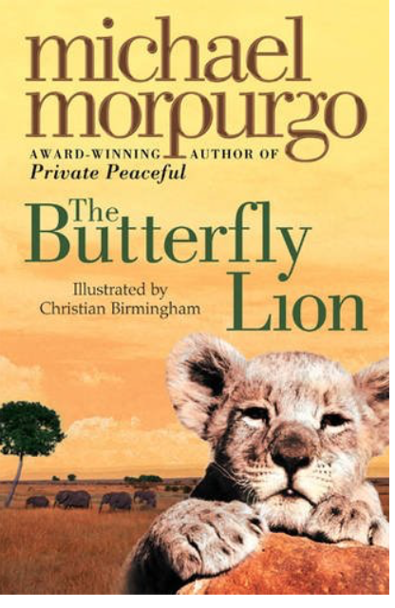

‘The Amazing Story of Adolphus Tips’
E.B.White-‘Charlotte’s Web’ and ‘Stuart Little’
Philip Pullman-‘The Fire-Maker’s Daughter
Jill Murphy’ The Worst Witch Series
Ted Hughes-‘The Iron Man’

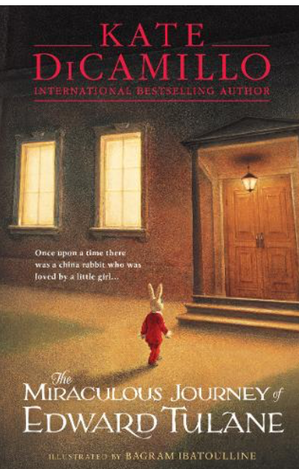
Brian Selznick-‘The Invention of Huge Cabret’
Kate DiCamillo-‘The Tale of Despereaux’
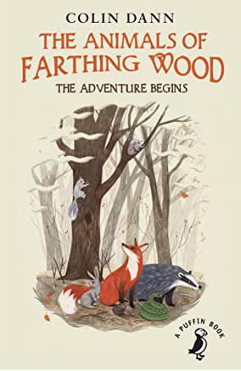
Chris Riddell-‘Ottoline and the Yellow Cat’ series
-Nina Bawden- ‘The Peppermint Pig’
Colin Dann-‘Animals of Farthing Wood Series’
Astrid Lindgren-‘Pippi Longstocking’
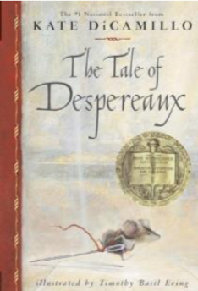
Hannah Gold-‘The Last Bear’
Tony Diterlizzi-The Spiderwick Chronicles
Erich Kastner-‘Emil and the Detectives’
Cressida Cowell-Train your Dragon series
Ursula Moray Williams’’Gobolino the Witch’s Cat’
Katie Tsang-‘Dragon Mountain’
A.B.Martin-‘Kestral IslanWW

